**Visual F-CAP work instructions**

(The reader is advised to read the instructions manual first for detailed information. The following passages “in blue” are extracted from the manual).

The following figures relate to the GBTM/F-CAP analysis of the Montreal data (available on the proc traj website <http://www.andrew.cmu.edu/user/bjones/cnorm.htm>). The outcome was ‘*opposition scores’*. The example provided is run in the “FULL” mode.

Open the R-code and

“Adjust the user settings according to your situation”:

For the opposition scores data: the outcome variable (**o1-o7**) was measured over 7 time points (**t1-t7**), the link function is censored Normal (**CNORM**), the largest number of latent trajectories was set to be (k=**10**), and the highest order of polynomial order considered was cubic (**3**):

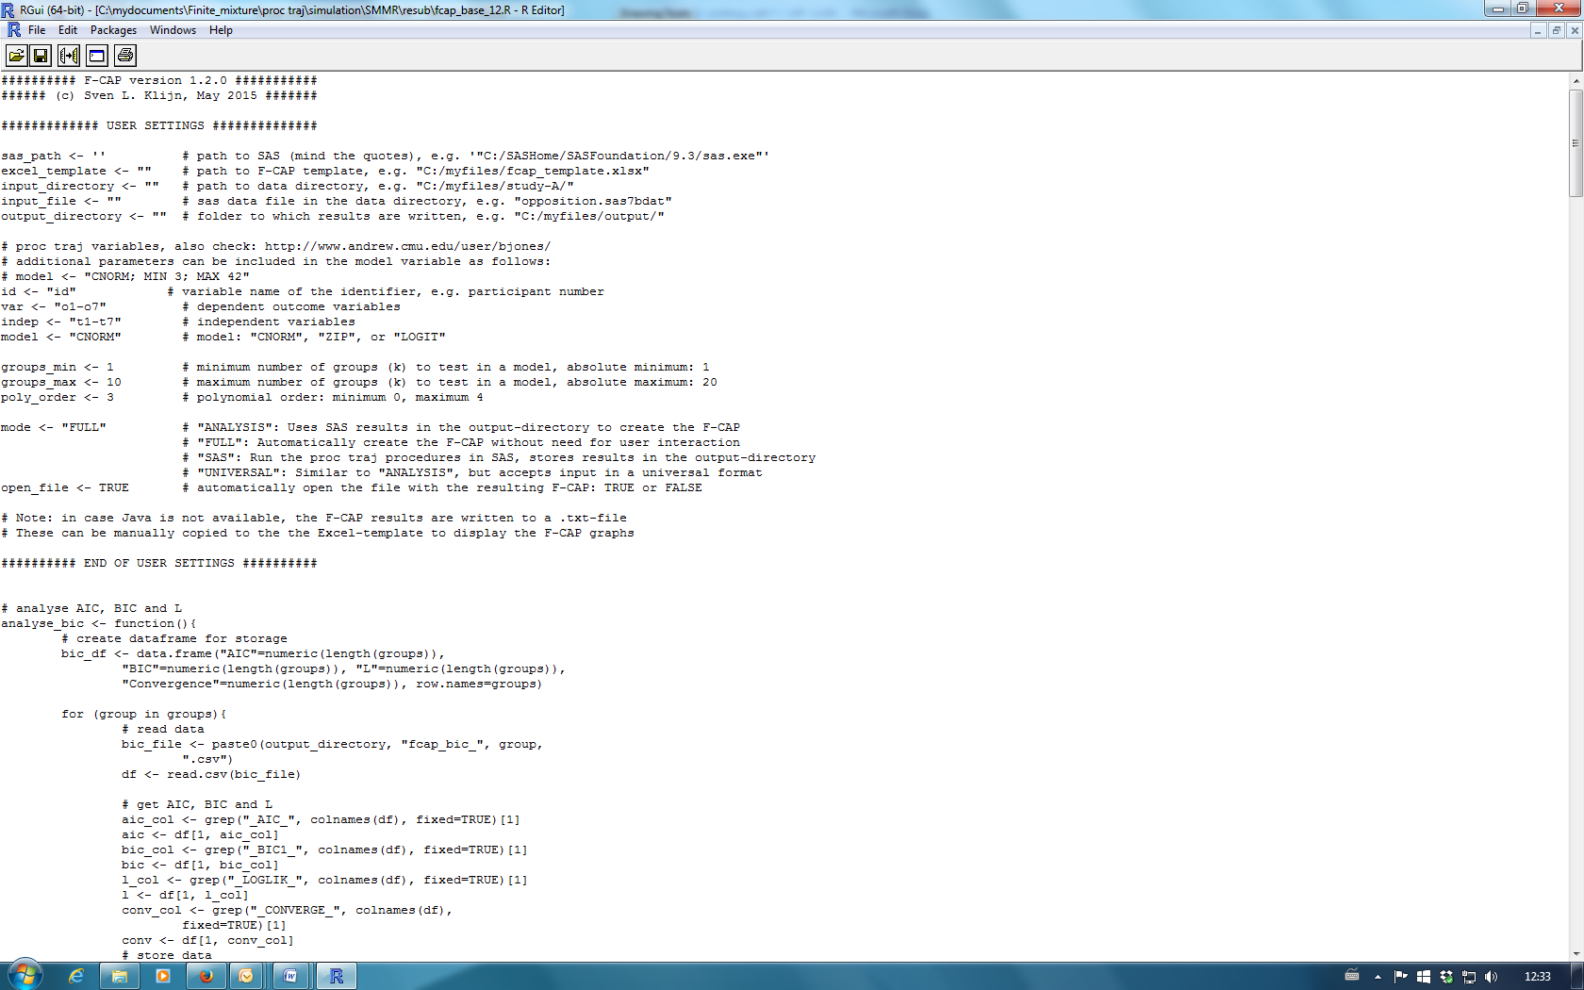

“Run the F-CAP R-program. Please note that the calculations in SAS may take a long time, depending on the size of the dataset, the maximum value of ‘k’ and the speed of your system”

If everything runs smoothly, (even without JAVA, thus the ‘error’ message below), the **R-console** window should show the following message:

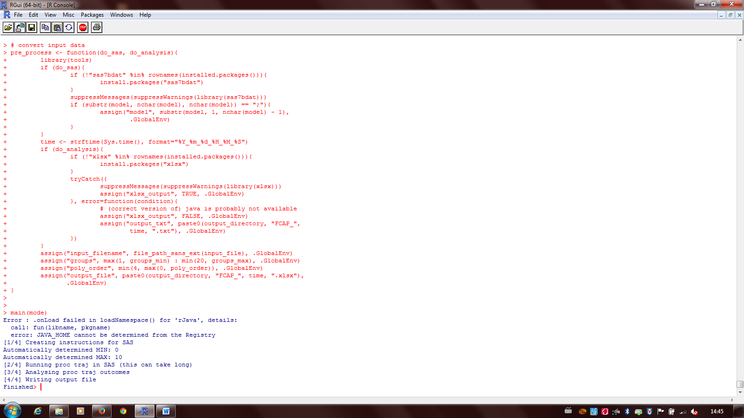

“The output consists of a series of .csv files in the output folder” (in this regard, see please ‘caution’ comment on page 5)

After the program is finished, the .txt file and the excel template should open automatically:

The excel template has two views:

The plots view (still empty):

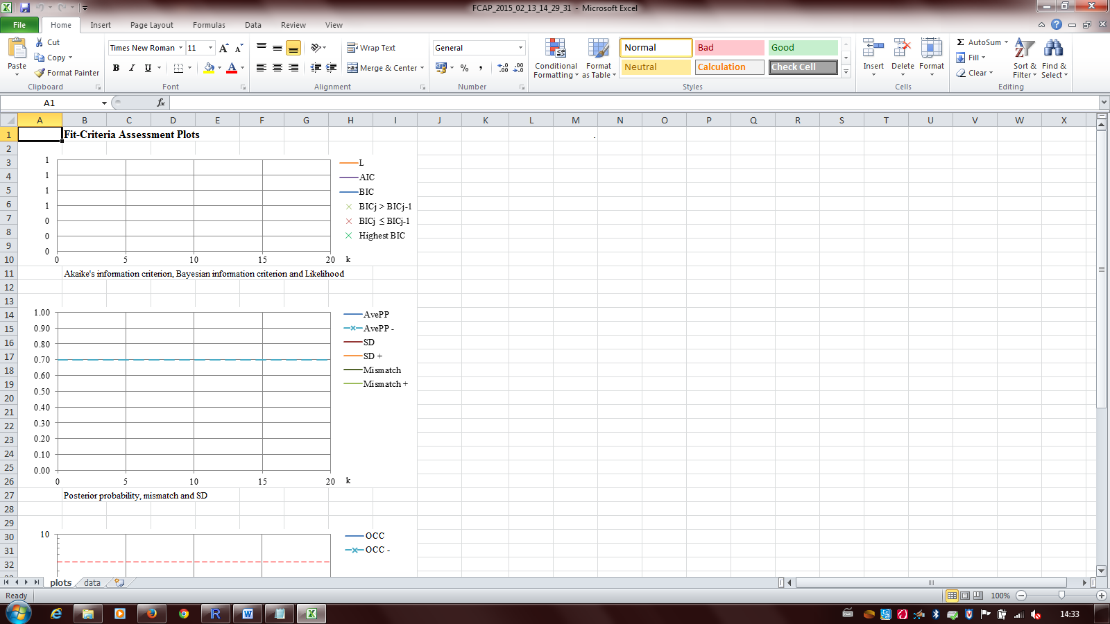

And the data view (also empty):

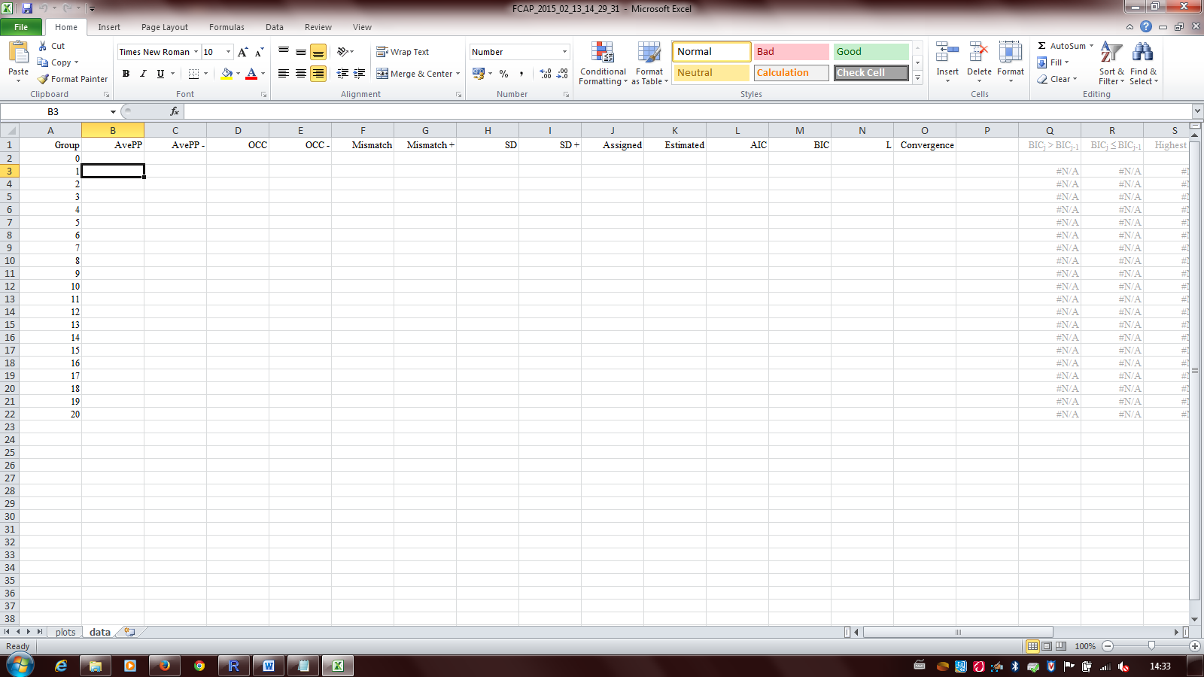

The text file (that opens automatically) has all necessary information for the construction of the F-CAP:

“Select all values in the F-CAP text-file (ctrl+A), copy them (ctrl+C), and paste them in the F-CAP Excel-file on the data-sheet in cell B3 (ctrl+V).”

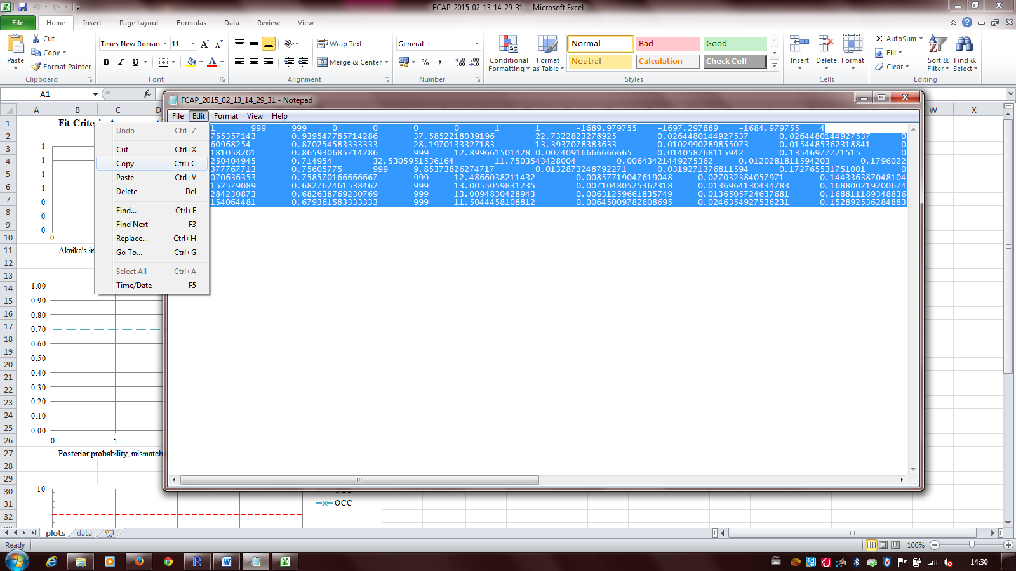

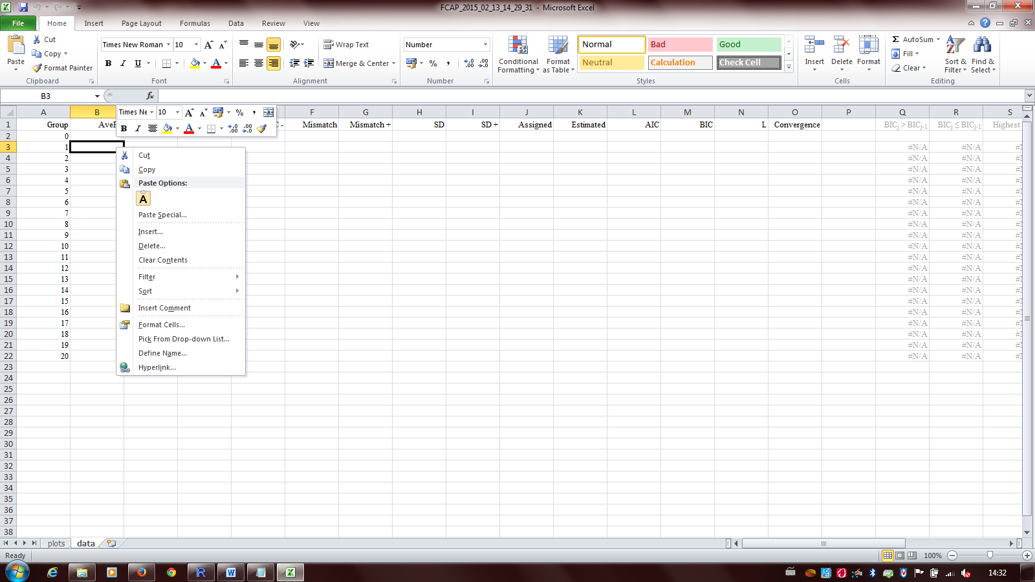

And you will get:

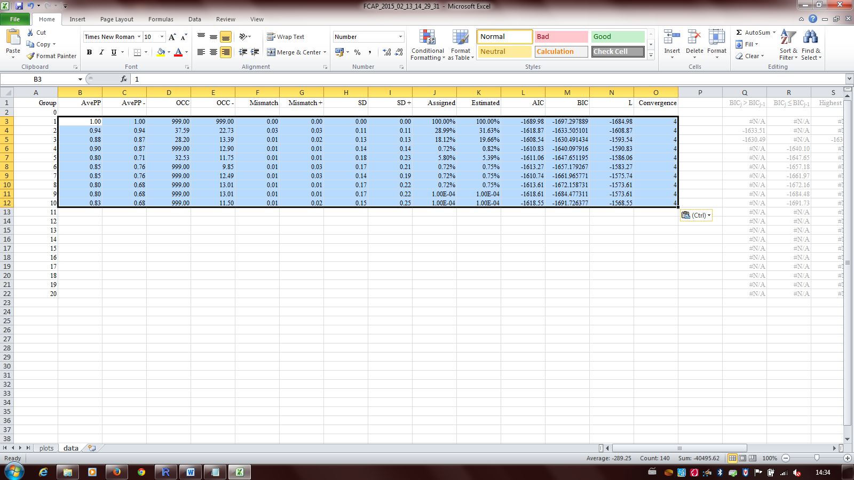

Switch to the plots view to get the F-CAPs:

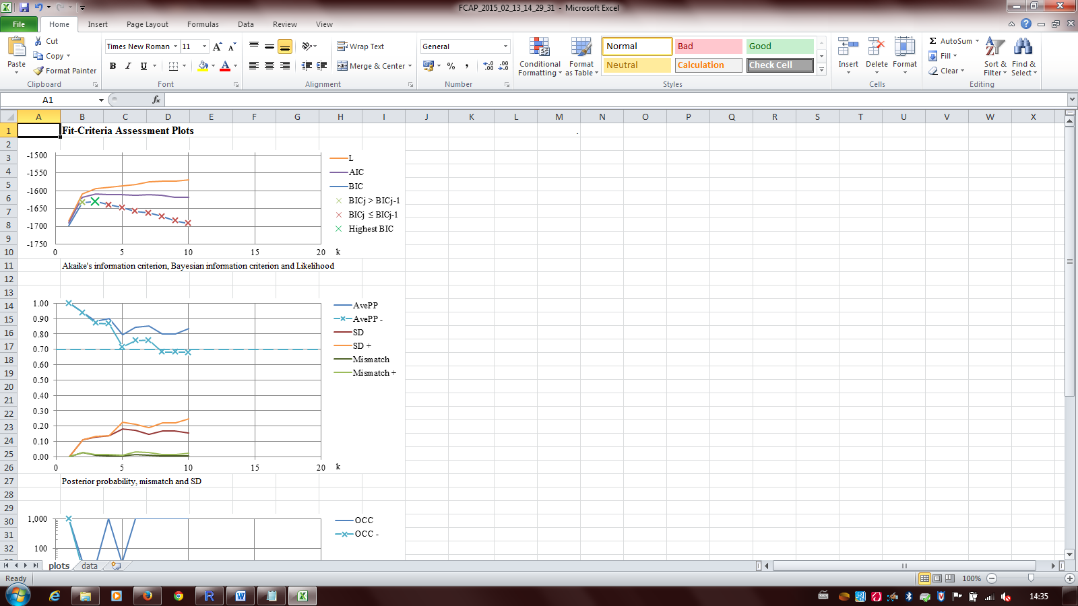

**Caution:** Before running F-CAP code for a new dataset, make sure to delete the intermediary files (fcap.sas, excel and the txt file with the F-CAP results) created in the output directory:

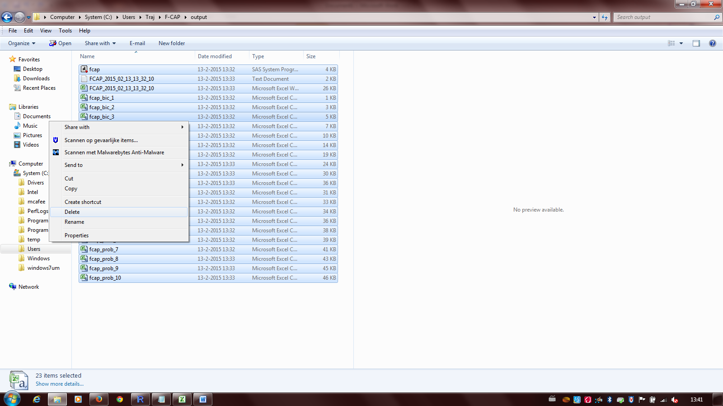

**The CAMBRIDGE DATA ANALYSIS (**[**http://www.andrew.cmu.edu/user/bjones/zip.htm**](http://www.andrew.cmu.edu/user/bjones/zip.htm)**):**

**The R-code:**

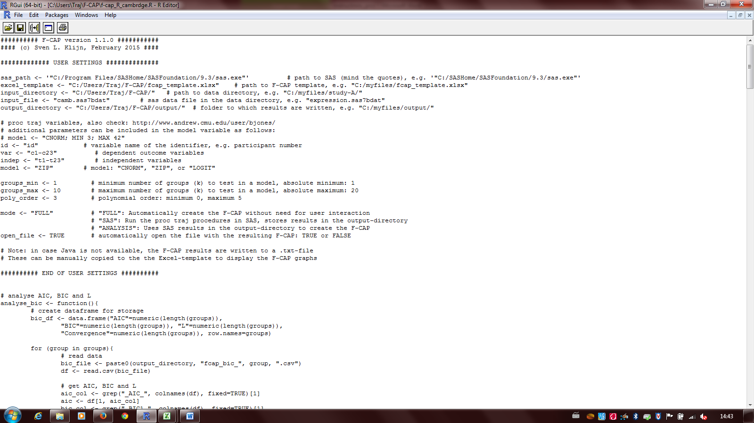

Note that the users’ settings have been altered compared to the previous example:

**The F-CAP:**

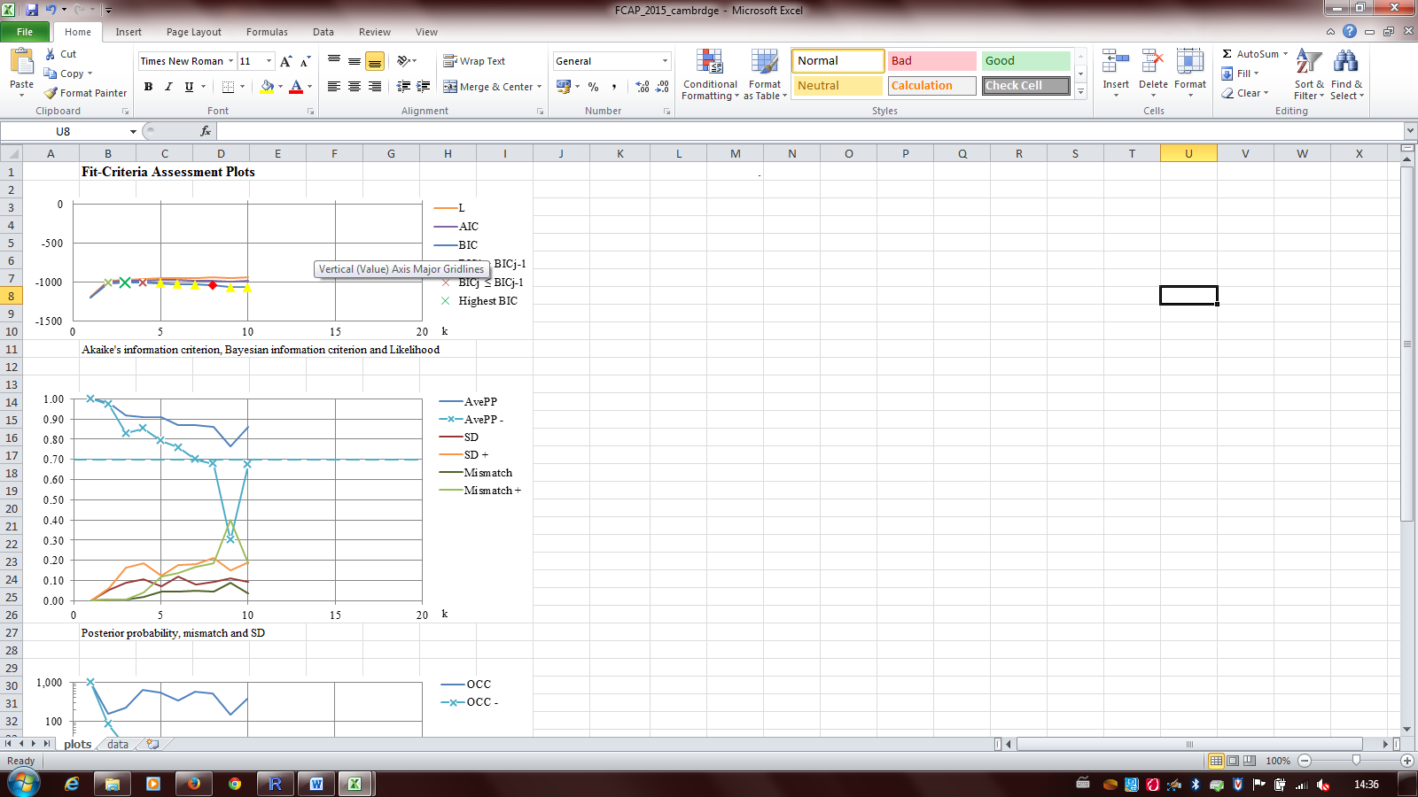

We want to draw your attention to the yellow triangle and red lozenge in the BIC curve, indicating models with singular and false convergence, respectively: